How to Sign up for Exams at SDAC

At least ONE WEEK before each test, talk to your professor about arrangements for your exam. Either:
  - Your professor (or their teaching assistants) will make the arrangements on their own. In this case, you do not need to contact SDAC unless you encounter problems.

  - Your professor directs you to take your exam at SDAC. In this case, you will need to follow the steps on the next page.

Terms and Conditions of Taking Exams at SDAC:
- You must have arranged it with your professor before scheduling your exams at SDAC.
- In general, you are expected to take your exam at the same date/time as the rest of the class. Please discuss any changes with your professor.
- Exams should be scheduled 5 days in advance.
- Please arrive on time and ready to start – your time may be deducted if you arrive late.

Testing Hours:
- Exams/Quizzes: Mon – Fri 8:00 AM – 4:45 PM (All exams must be turned in by 4:45 PM)
- Finals: Mon – Sat 8:00 AM – 10:00 PM (For 1.5x extended time, start times are 9:00 AM, 2:00 PM, or 5:30 PM; For 2.0x extended time, start times are 9:00 AM, 2:00 PM, or 4:00 PM)

Continue to next page

Scheduling your exam at SDAC
First, Log into the SDAC portal using your net badge login: SDAC Portal
- Under My Accommodations on the left, click “Alternate Testing”.
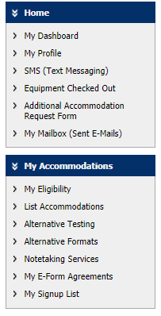
Step 1
- Select Class from drop-down menu and click “Schedule an Exam”.
- If your course does not show up, make sure that you have an alternative testing contract on file for that class, which tells us how to proctor the exam. There is a training for this below.
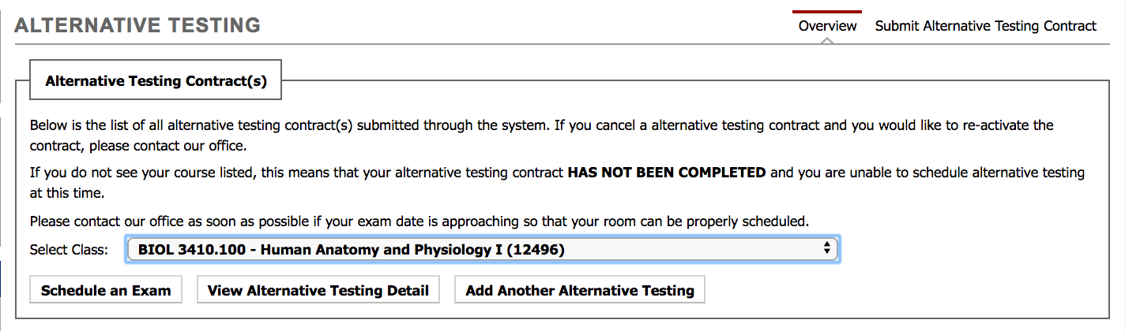
Step 2
- Fill out the Exam Detail form and click “Add Exam Request”.
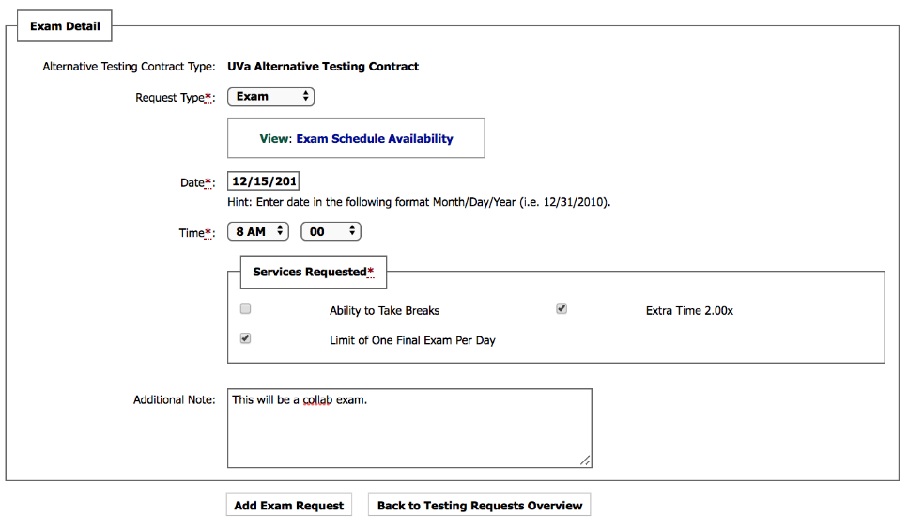
Step 3
- Check back in 24-48 hours to see if you request has been approved. If approved, this means we have space for you at SDAC, and you’re all set. Otherwise, you will have a message that your request is denied or the exam needs to be rescheduled.

Here is a link to a more detailed video about this topic: Alternative Testing Video

