How to sign up to be a Peer Notetaker with SDAC

First, click on the link below. This link was also sent out in the email from your professor.
SDAC Notetaker Application

- Sign into the portal.
  - The school ID is your computing ID plus 0’s in the front to make it 7 digits. So for example sh2aw would be 00sh2aw.
  - For the Email Address please use your @virginia.edu email.
  - If you have been registered with our office before it will show up as an error. Please email us at sdac@virginia.edu and we will reset your account!

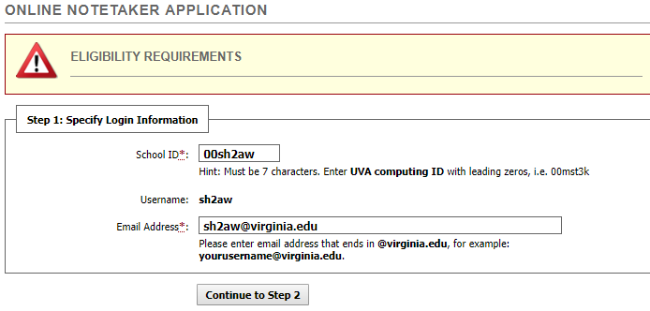
Step 1

- Complete the Online Notetaker Application, then click register as notetaker on the bottom. A screen shot of this is shown on the next page.
Continue to next page
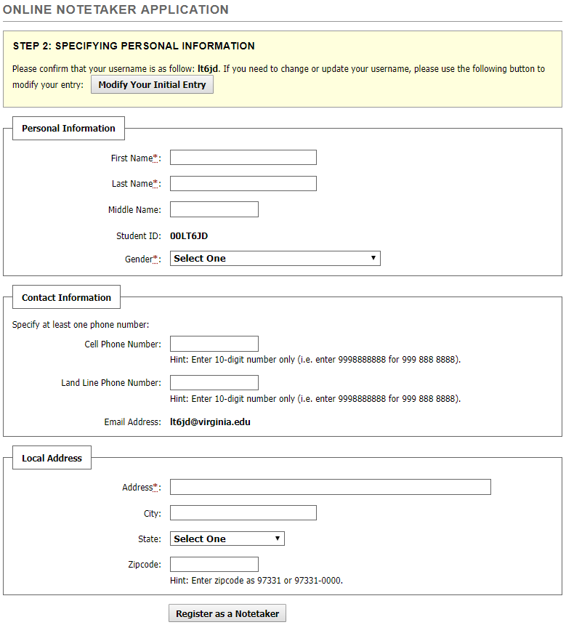
[Grab your reader’s attention with a great quote from the document or use this space to emphasize a key point. To place this text box anywhere on the page, just drag it.]
Step 2

- Now sign in to the online services. Your username is your computing id for example (sh2aw) and your password is your Netbadge password.
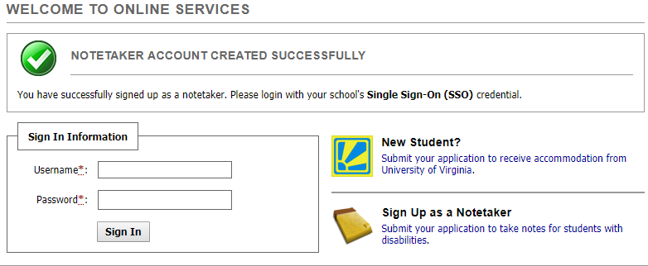
Step 3

- Click the Notetaker tab on the top right. 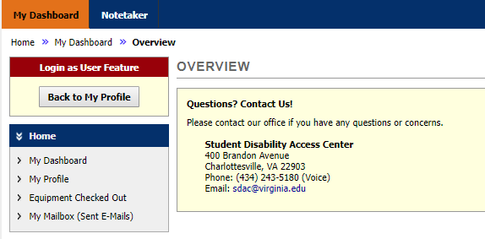
Step 4
- Search for your course you want to take notes for, then verify your classes.
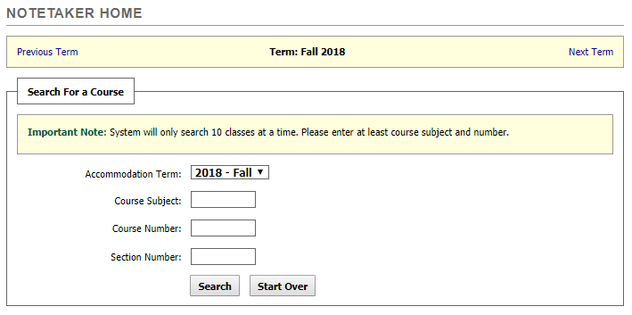
Step 5
- Your class should populate then click select.
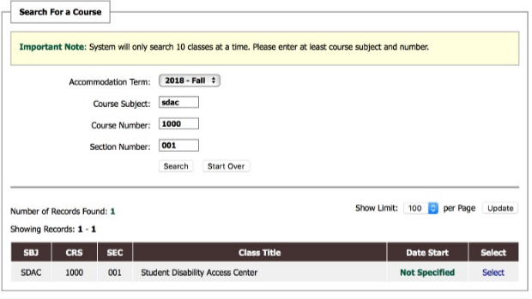
Step 6
- Verify your classes by clicking the box for the class(s) you want to take notes for then click submit your class schedule.
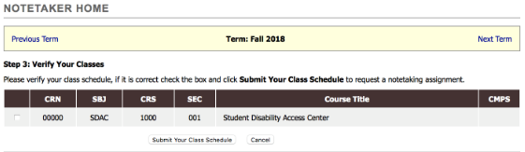
Step 7

- Thank you for signing up to be a notetaker! Once assigned as a notetaker, you can upload your notes. (See the training on uploading notes).

