Peer-Notes in SDAC AIM
First, Log into the SDAC portal using your net badge login: SDAC Portal
- Click the notetaking tab on the top bar.

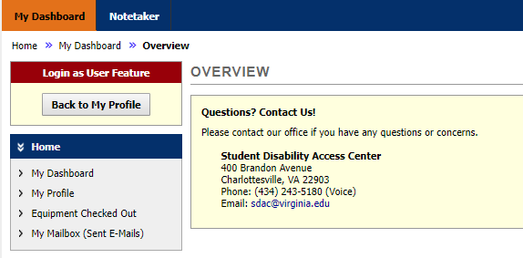
Step 1
- Scroll down to “File information.” Select your class. Under notes for choose the week the notes were taken. Choose the day or days of the class (s). Then add your file and click upload. 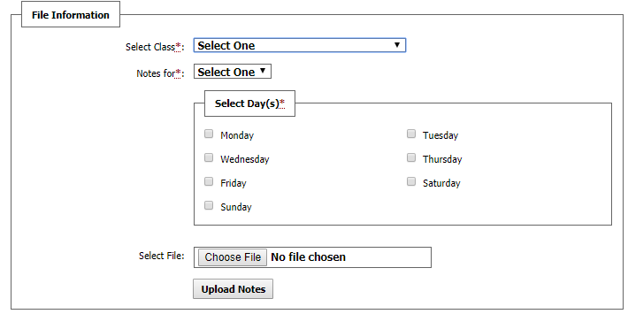
Step 2

Acceptable File types:
The maximum file size is 3MB.

Rich Text File (RTF), Text File (TXT), Microsoft Word (DOC or DOCX), Microsoft Excel (XLS or XLSX), PDF Document (Scan with 300 DPI or less), Image (PNG, JPEG, or JPG), Microsoft PowerPoint (PPT or PPTX) Not Recommended Due to Size

- To look at all of the notes you have uploaded scroll up to the course menu. Click View.
Step 3
- Scroll down and you can find a list of the notes you have uploaded. To view all of them click view all uploaded files.
